|  |
| --- |
| IFMR RURAL FINANCE |
| Credit Committee Review |
|  |
| **IFMR Rural Finance** |
| **8/11/2016** |

|  |
| --- |
|  |

Contents

Process Diagram 3

1. Stage definition 4

2. Stage-role access 4

3. Credit Committee review Queue 4

3.1 UI specification 4

3.2 Screenshot 5

3.3 Functional requirements 6

3.4 Upload 6

3.5 Download 6

3.6 Reports 6

4. Capturing data 7

4.1 UI requirements 7

4.2 Screenshots 30

4.3 Functional requirements 65

4.4 Uploads 65

4.5 Downloads 65

4.6 Reports 65

5. Risk Score 3 65

5.1 UI specification 65

5.2 Screenshot 65

5.3 Functional requirements 65

5.4 Upload 65

5.5 Download 65

5.6 Reports 65

# Process Diagram



# Stage definition

|  |  |
| --- | --- |
| **Stage** | **Description** |
| Credit Committee Review Queue | The Credit committee member selects a profile from the pending for credit committee review queue (i.e. completed field appraisal review) |
| Credit Committee Remarks | The Credit committee reviews Application and give their remarks |
| Decision | The credit committee can Accept, Reject or send back the application |

# Stage-role access

|  |  |
| --- | --- |
| **Stage** | **Applicable Role** |
| Credit Committee Review Queue | Credit committee member |
| Credit Committee Remarks | Credit committee member |
| Decision | Credit committee |

# Credit Committee review Queue

## UI specification

|  |  |  |  |  |
| --- | --- | --- | --- | --- |
| **Field name** | **Section** | **Data Type** | **Attribute** | **Population logic** |
| S. No. | Credit Committee Review Queue | Numeric |  |  |
| Hub Name | Credit Committee Review Queue | Text | Sort/search | From Central Risk review stage |
| Spoke Name | Credit Committee Review Queue | Text | Sort/search | From Central Risk review stage |
| Applicant Name | Credit Committee Review Queue | Text | Sort/search | From Central Risk review stage |
| Business Name | Credit Committee Review Queue | Alphanumeric | Sort/search | From Central Risk review stage |
| URN No | Credit Committee Review Queue | Alphanumeric | Sort/search | From Central Risk review stage |
| Area | Credit Committee Review Queue | Text | Sort/search | From Central Risk review stage |
| City/Village/ Town | Credit Committee Review Queue | Text | Sort/search | From Central Risk review stage |
| Pincode | Credit Committee Review Queue | Numeric |  | From Central Risk review stage |

## Screenshot

* + 1. Search Page

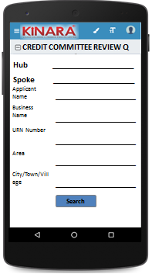

* + 1. Field Appraisal Review Queue

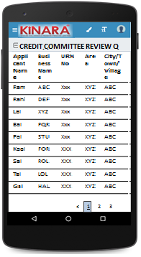

## Functional requirements

**Credit committee member** logs in

* The CC member opens the process dash board, and clicks on Credit committee Review queue
* If the CC member performs a search without selecting any parameter, then all cases with status ‘Pending for Field Appraisal Review’ to be displayed in a tabular format.
* If the CC member searches with ‘Applicant name’, ‘Business name’ or ‘URN no’, then all matching records that are ‘Pending for Credit committee Review’ (including existing customers) to be displayed in a tabular format.
* The CC member can **search and sort** the profiles based on the following parameters: URN no, Applicant Name, Business Name, Area, City/Village/Town.
* The CC member then selects a profile from the field appraisal review queue. The queue table should have applicant name, business name, URN No, Area, City/Town/Village as column names.
* All the columns will have **sorting** facility.

## Upload

-NA-

## Download

-NA-

## Reports

-NA-

# Capturing data

## UI requirements

|  |  |  |  |  |  |  |  |  |
| --- | --- | --- | --- | --- | --- | --- | --- | --- |
| **Entity** | **Tab** | **Sub tab** | **Section** | **Fields** | **Field Value** | **Mandatory** | **Conditional Mandatory** | **Remarks** |
| **Central Risk Review** | **Summary** | Ratios |  |  |  |  |  |  |
| Scenarios |  |  |  |  |  |  |
| **Risk Scores** | Risk Score 1 |  |  |  |  |  |
| Risk Score 2 |  |  |  |  |  |
| Risk Score 3 |  |  |  |  |  |
| Psychometric Score |  |  |  |  |  |
| **CB Check Reports** |  | Applicant |  |  |  |  |  |
| Co-Applicant |  |  |  |  |  |
| Business |  |  |  |  |  |
| **Reference Check** |  | Applicant | Full Name | Text |  |  | Auto-populate from Central risk review but not editable |
| Mobile No | Numeric |  |  | Auto-populate from Central risk review but not editable |
| Occupation | Text |  |  | Auto-populate from Central risk review but not editable |
| Remarks | Alphanumeric |  |  | Auto-populate from Central risk review but not editable |
|  | Business | Business Name | Alphanumeric |  |  | Auto-populate from Central risk review but not editable |
| Business Sector | Alphanumeric |  |  | Auto-populate from Central risk review but not editable |
| Full Name of POC | Text |  |  | Auto-populate from Central risk review but not editable |
| Mobile Number | Numeric |  |  | Auto-populate from Central risk review but not editable |
| Remarks | Alphanumeric |  |  | Auto-populate from Central risk review but not editable |
| **APPLICANT** | **KYC Details** |  |  | Aadhar No | Numeric | Yes |  | Auto-populate from Central risk review but not editable |
| Document Capture | Upload | Yes |  | Auto-populate from Central risk review but not editable |
| Pan Number | Alpha numeric | Yes |  | Auto-populate from Central risk review but not editable |
| Document Capture | Upload | Yes |  | Auto-populate from Central risk review but not editable |
| ID Type | Dropdown |  |  | Auto-populate from Central risk review but not editable |
| ID No | Alpha numeric |  | Yes | Auto-populate from Central risk review but not editable |
| Valid Up to | Date |  |  | Auto-populate from Central risk review but not editable |
| Document Capture |  |  | Yes | Auto-populate from Central risk review but not editable |
| **Applicant Details** |  |  | Title | Text | Yes |  | Auto-populate from Central risk review but not editable |
| Name | Text | Yes |  | Auto-populate from Central risk review but not editable |
| Gender | Text | Yes |  | Auto-populate from Central risk review but not editable |
| Date Of birth | Text | Yes |  | Auto-populate from Central risk review but not editable |
| Age | Text |  |  | Auto-populate from Central risk review but not editable |
| Father's Name | Text | Yes |  | Auto-populate from Central risk review but not editable |
| Educational Level | Dropdown | Yes |  | Auto-populate from Central risk review but not editable |
| Religion | Dropdown | Yes |  | Auto-populate from Central risk review but not editable |
| Mobile No | Numeric | Yes |  | Auto-populate from Central risk review but not editable |
| Alternate Mobile No. | Numeric |  |  | Auto-populate from Central risk review but not editable |
| WhatsApp Mobile No. | Numeric |  |  | Auto-populate from Central risk review but not editable |
| Email ID | Alphanumeric,  special characters |  |  | Auto-populate from Central risk review but not editable |
| Preferred language of communication | Dropdown | Yes |  | Auto-populate from Central risk review but not editable |
| Mother's Name | Text |  |  | Auto-populate from Central risk review but not editable |
| Marital Status | Dropdown | Yes |  | Auto-populate from Central risk review but not editable |
| Auto-populate from Central risk review but not editable |
| Spouse Name | Text |  |  | Auto-populate from Central risk review but not editable |
| Relationship with Business | Dropdown | Yes |  | Auto-populate from Central risk review but not editable |
| Business Involvement | Dropdown | Yes |  | Auto-populate from Central risk review but not editable |
| Have you ever been a proprietor or partner of any other company | Radio Buttons |  |  | Auto-populate from Central risk review but not editable |
| If yes, did the business close? | Radio Buttons |  |  | Auto-populate from Central risk review but not editable |
| Month/Year (of business closure) | Date |  |  | Auto-populate from Central risk review but not editable |
| **Address Details** |  |  | Type Of Address | Dropdown | Yes |  | Auto-populate from Central risk review but not editable |
| Care of | Text |  |  | Auto-populate from Central risk review but not editable |
| Building | Alphanumeric, special characters | Yes |  | Auto-populate from Central risk review but not editable |
| Street | Alphanumeric, special characters |  |  | Auto-populate from Central risk review but not editable |
| Landmark | Alphanumeric, special characters |  |  | Auto-populate from Central risk review but not editable |
| Locality | Alphanumeric, special characters |  |  | Auto-populate from Central risk review but not editable |
| Pin Code | Numeric | Yes |  | Auto-populate from Central risk review but not editable |
| Village/Town/City | Text | Yes |  | Auto-populate from Central risk review but not editable |
| District | Text | Yes |  | Auto-populate from Central risk review but not editable |
| State | Text | Yes |  | Auto-populate from Central risk review but not editable |
| Country | Text | Yes |  | Auto-populate from Central risk review but not editable |
| Location | GPS coordinates | Yes |  | Auto-populate from Central risk review but not editable |
| Is the Communication Address same as the Aadhar Card address? | Radio Buttons | Yes |  | Auto-populate from Central risk review but not editable |
| Line 1 | Alpha numeric |  | Yes | Auto-populate from Central risk review but not editable |
| Line 2 | Alpha numeric |  |  | Auto-populate from Central risk review but not editable |
| Area | Alpha numeric |  |  | Auto-populate from Central risk review but not editable |
| Land Mark | Alpha numeric |  | Yes | Auto-populate from Central risk review but not editable |
| Pin Code | Numeric |  | Yes | Auto-populate from Central risk review but not editable |
| State | Text |  | Yes | Auto-populate from Central risk review but not editable |
| District | Text |  | Yes | Auto-populate from Central risk review but not editable |
| City/Town/Village | Text |  | Yes | Auto-populate from Central risk review but not editable |
| Ownership | Dropdown | Yes |  | Auto-populate from Central risk review but not editable |
| How many years are you living in present Area? | Dropdown | Yes |  | Auto-populate from Central risk review but not editable |
| How many years are you living in current Address? | Dropdown | Yes |  | Auto-populate from Central risk review but not editable |
| Is the Communication Address same as Permanent Address? | Radio Buttons | Yes |  | Auto-populate from Central risk review but not editable |
| **Family Member Details** |  |  | Name | Text |  |  | Auto-populate from Central risk review but not editable |
| Relationship with applicant | Dropdown |  |  | Auto-populate from Central risk review but not editable |
| Profession | Dropdown |  |  | Auto-populate from Central risk review but not editable |
| Salary | Numeric |  |  | Auto-populate from Central risk review but not editable |
| Education fee (annual) | Numeric |  |  | Auto-populate from Central risk review but not editable |
| Is a Co-applicant? | Radio Buttons |  |  | Auto-populate from Central risk review but not editable |
| **Household Financials** |  |  | Other Income Source | Dropdown |  |  | Auto-populate from Central risk review but not editable |
| Amount | Numeric |  |  | Auto-populate from Central risk review but not editable |
| Expense Type | Dropdown |  |  | Auto-populate from Central risk review but not editable |
| Amount | Numeric |  |  | Auto-populate from Central risk review but not editable |
| Monthly Education Expenses | Auto Calculated |  |  | Auto-populate from Central risk review but not editable |
| Family Exp. Based on Education expense | Auto Calculated |  |  | Auto-populate from Central risk review but not editable |
| Asset Type | Dropdown |  |  | Auto-populate from Central risk review but not editable |
| Vehicle make & model | Alphanumeric |  | Yes | Auto-populate from Central risk review but not editable |
| Registered Owner | Alpha |  | Yes | Auto-populate from Central risk review but not editable |
| Value of the asset | Numeric |  | Yes | Auto-populate from Central risk review but not editable |
| **Liabilities** |  |  | Debt Source | Dropdown |  |  | Auto-populate from Central risk review but not editable |
| Creditor's Name | Alphanumeric |  |  | Auto-populate from Central risk review but not editable |
| Loan Amount | Numeric |  |  | Auto-populate from Central risk review but not editable |
| Loan Outstanding | Numeric |  |  | Auto-populate from Central risk review but not editable |
| Loan term | Alphanumeric |  |  | Auto-populate from Central risk review but not editable |
| Monthly Instalment | Numeric |  |  | Auto-populate from Central risk review but not editable |
| No. of instalment Paid | Numeric |  |  | Auto-populate from Central risk review but not editable |
| Purpose | Dropdown |  |  | Auto-populate from Central risk review but not editable |
| **Bank Statement Details** |  |  | IFSC Code | Numeric |  |  | Auto-populate from Central risk review but not editable |
| Bank Name | Alphanumeric | Yes |  | Auto-populate from Central risk review but not editable |
| Branch Name | Text |  |  | Auto-populate from Central risk review but not editable |
| A/C name | Alphanumeric | Yes |  | Auto-populate from Central risk review but not editable |
| A/C type | Text | Yes |  | Auto-populate from Central risk review but not editable |
| A/C no | Numeric | Yes |  | Auto-populate from Central risk review but not editable |
| Banking since | Date |  |  | Auto-populate from Central risk review but not editable |
| Net banking available | Radio Buttons | Yes |  | Auto-populate from Central risk review but not editable |
| Sanctioned Amount | Numeric |  | Yes | Auto-populate from Central risk review but not editable |
| Start Month | Date | Yes |  | Auto-populate from Central risk review but not editable |
| Total Deposits | Numeric | Yes |  | Auto-populate from Central risk review but not editable |
| Total Withdrawals | Numeric | Yes |  | Auto-populate from Central risk review but not editable |
| Balance as on 15th | Numeric | Yes |  | Auto-populate from Central risk review but not editable |
| No of cheques bounced | Numeric | Yes |  | Auto-populate from Central risk review but not editable |
| No of EMI cheques bounced | Numeric | Yes |  | Auto-populate from Central risk review but not editable |
| **References** |  |  | Reference Type | Dropdown | Yes |  | Auto-populate from Central risk review but not editable |
| Full Name | Alphanumeric |  |  | Auto-populate from Central risk review but not editable |
| Mobile No | Numeric |  |  | Auto-populate from Central risk review but not editable |
| Occupation | Dropdown |  |  | Auto-populate from Central risk review but not editable |
| Self-reported Income | Numeric |  |  | Auto-populate from Central risk review but not editable |
| **Proxy Indicators** |  |  | Proper & Matching Signboard | Radio Buttons | Yes |  | Auto-populate from Central risk review but not editable |
| Bribe Offered | Radio Buttons | Yes |  | Auto-populate from Central risk review but not editable |
| Shop/Shed Organized | Radio Buttons | Yes |  | Auto-populate from Central risk review but not editable |
| In Industrial Area | Radio Buttons | Yes |  | Auto-populate from Central risk review but not editable |
| Customer Attitude to Kinara | Radio Buttons | Yes |  | Auto-populate from Central risk review but not editable |
| Book-keeping Quality | Radio Buttons | Yes |  | Auto-populate from Central risk review but not editable |
| Challenging cheque bounce/fee charge/policies | Radio Buttons | Yes |  | Auto-populate from Central risk review but not editable |
| All Machines operational? | Radio Buttons | Yes |  | Auto-populate from Central risk review but not editable |
| Employee Satisfaction | Radio Buttons | Yes |  | Auto-populate from Central risk review but not editable |
| Political/Police Connections | Radio Buttons | Yes |  | Auto-populate from Central risk review but not editable |
| Multiple Products (more than 3) | Radio Buttons | Yes |  | Auto-populate from Central risk review but not editable |
| Multiple Buyers (more than 3) | Radio Buttons | Yes |  | Auto-populate from Central risk review but not editable |
| Seasonal Business | Radio Buttons | Yes |  | Auto-populate from Central risk review but not editable |
| Income Stability | Radio Buttons | Yes |  | Auto-populate from Central risk review but not editable |
| Utilization of business premises | Radio Buttons | Yes |  | Auto-populate from Central risk review but not editable |
| Approach for the business premises | Radio Buttons | Yes |  | Auto-populate from Central risk review but not editable |
| Safety measures for employees | Radio Buttons | Yes |  | Auto-populate from Central risk review but not editable |
| Child labourers | Radio Buttons | Yes |  | Auto-populate from Central risk review but not editable |
| Is the business in effecting environment? | Radio Buttons | Yes |  | Auto-populate from Central risk review but not editable |
| Stock/ Material Management | Radio Buttons | Yes |  | Auto-populate from Central risk review but not editable |
|  |  |  |  |  |  |  |  | Auto-populate from Central risk review but not editable |
| **CO-APPLICANT** |  | **KYC Details** |  | Aadhar No | Numeric | Yes |  | Auto-populate from Central risk review but not editable |
| Document Capture | Upload | Yes |  | Auto-populate from Central risk review but not editable |
| Pan Number | Alpha numeric | Yes |  | Auto-populate from Central risk review but not editable |
| Document Capture | Upload | Yes |  | Auto-populate from Central risk review but not editable |
| ID Type | Dropdown |  |  | Auto-populate from Central risk review but not editable |
| ID No | Alpha numeric |  | Yes | Auto-populate from Central risk review but not editable |
| Valid Up to | Date |  | Yes | Auto-populate from Central risk review but not editable |
| Document Capture | Upload |  | Yes | Auto-populate from Central risk review but not editable |
| **Co-Applicant Details** |  |  | Title | Text | Yes |  | Auto-populate from Central risk review but not editable |
| Name | Text | Yes |  | Auto-populate from Central risk review but not editable |
| Gender | Text | Yes |  | Auto-populate from Central risk review but not editable |
| Date Of birth | Date | Yes |  | Auto-populate from Central risk review but not editable |
| Age | Numeric |  |  | Auto-populate from Central risk review but not editable |
| Auto-populate from Central risk review but not editable |
| Father's Name | Text | Yes |  | Auto-populate from Central risk review but not editable |
| Educational Level | Dropdown | Yes |  | Auto-populate from Central risk review but not editable |
| Religion | Dropdown | Yes |  | Auto-populate from Central risk review but not editable |
| Mobile No | Numeric | Yes |  | Auto-populate from Central risk review but not editable |
| Alternate Mobile No. | Numeric |  |  | Auto-populate from Central risk review but not editable |
| WhatsApp Mobile No. | Numeric |  |  | Auto-populate from Central risk review but not editable |
| Email ID | Alphanumeric, special characters |  |  | Auto-populate from Central risk review but not editable |
| Preferred language of communication | Dropdown | Yes |  | Auto-populate from Central risk review but not editable |
| Auto-populate from Central risk review but not editable |
| Mothers Name | Text |  |  | Auto-populate from Central risk review but not editable |
| Marital Status | Dropdown | Yes |  | Auto-populate from Central risk review but not editable |
| Spouse Name | Text |  | Yes | Auto-populate from Central risk review but not editable |
| Relationship with Applicant | Text | Yes |  | Auto-populate from Central risk review but not editable |
| Relationship with Business | Dropdown | Yes |  | Auto-populate from Central risk review but not editable |
| Business Involvement | Dropdown | Yes |  | Auto-populate from Central risk review but not editable |
| Have you ever been a proprietor or partner of any other company | Radio Buttons |  |  | Auto-populate from Central risk review but not editable |
| If yes, did the business close? | Radio Buttons |  |  | Auto-populate from Central risk review but not editable |
| Month/Year (of business closure) | Date |  |  | Auto-populate from Central risk review but not editable |
| **Address Details** |  |  | Type Of Address | Dropdown | Yes |  | Auto-populate from Central risk review but not editable |
| Care of | Text |  |  | Auto-populate from Central risk review but not editable |
| Building | Alphanumeric, special characters | Yes |  | Auto-populate from Central risk review but not editable |
| Street | Alphanumeric, special characters |  |  | Auto-populate from Central risk review but not editable |
| Landmark | Alphanumeric, special characters |  |  | Auto-populate from Central risk review but not editable |
| Locality | Alphanumeric, special characters |  |  | Auto-populate from Central risk review but not editable |
| Pincode | Numeric | Yes |  | Auto-populate from Central risk review but not editable |
| Village/Town/City | Text | Yes |  | Auto-populate from Central risk review but not editable |
| District | Text | Yes |  | Auto-populate from Central risk review but not editable |
| State | Text | Yes |  | Auto-populate from Central risk review but not editable |
| Country | Text | Yes |  | Auto-populate from Central risk review but not editable |
| Location | GPS coordinates |  |  | Auto-populate from Central risk review but not editable |
| Is the Communication Address same as the Aadhar Card address? | Radio Buttons | Yes |  | Auto-populate from Central risk review but not editable |
| Line 1 | Alpha numeric |  | Yes | Auto-populate from Central risk review but not editable |
| Line 2 | Alpha numeric |  |  | Auto-populate from Central risk review but not editable |
| Area | Alpha numeric |  |  | Auto-populate from Central risk review but not editable |
| Land Mark | Alpha numeric |  | Yes | Auto-populate from Central risk review but not editable |
| Pin Code | Numeric |  | yes | Auto-populate from Central risk review but not editable |
| State | Auto populated |  | Yes | Auto-populate from Central risk review but not editable |
| District | Auto populated |  | Yes | Auto-populate from Central risk review but not editable |
| City/Town/Village | Auto populated |  | Yes | Auto-populate from Central risk review but not editable |
| Location (GPS) | GPS coordinates |  |  | Auto-populate from Central risk review but not editable |
| Ownership | Dropdown | Yes |  | Auto-populate from Central risk review but not editable |
| How many years are you living in present Area? | Dropdown | Yes |  | Auto-populate from Central risk review but not editable |
| How many years are you living in current Address? | Dropdown | Yes |  | Auto-populate from Central risk review but not editable |
| Is the Communication Address same as Permanent Address? | Radio Buttons | Yes |  | Auto-populate from Central risk review but not editable |
| **Family Member Details** |  |  | Name | Text |  |  | Auto-populate from Central risk review but not editable |
| Relationship with co-applicant | Text |  |  | Auto-populate from Central risk review but not editable |
| Profession | Text |  |  | Auto-populate from Central risk review but not editable |
| Salary | Numeric |  |  | Auto-populate from Central risk review but not editable |
| Education fee (annual) | Numeric |  |  | Auto-populate from Central risk review but not editable |
| **Household Financials** |  |  | Other Income Source | Dropdown |  |  | Auto-populate from Central risk review but not editable |
| Amount | Numeric |  |  | Auto-populate from Central risk review but not editable |
| Expense Type | Dropdown |  |  | Auto-populate from Central risk review but not editable |
| Amount | Numeric |  |  | Auto-populate from Central risk review but not editable |
| Monthly Education Expenses | Auto Calculated |  |  | Auto-populate from Central risk review but not editable |
| Family Exp. Based on Education expense | Auto Calculated |  |  | Auto-populate from Central risk review but not editable |
| Asset Type | Dropdown |  |  | Auto-populate from Central risk review but not editable |
| Vehicle make & model | Alphanumeric |  | Yes | Auto-populate from Central risk review but not editable |
| Registered Owner | Alpha |  | Yes | Auto-populate from Central risk review but not editable |
| Value of the asset | Numeric |  | Yes | Auto-populate from Central risk review but not editable |
| **Liabilities** |  |  | Debt Source | Dropdown |  |  | Auto-populate from Central risk review but not editable |
|  |  | Creditor's Name | Alphanumeric |  |  | Auto-populate from Central risk review but not editable |
|  |  | Loan Amount | Numeric |  |  | Auto-populate from Central risk review but not editable |
|  |  | Loan Outstanding | Numeric |  |  | Auto-populate from Central risk review but not editable |
|  |  | Loan term | Alphanumeric |  |  | Auto-populate from Central risk review but not editable |
|  |  | Monthly Instalment | Numeric |  |  | Auto-populate from Central risk review but not editable |
|  |  | No. of instalment Paid | Numeric |  |  | Auto-populate from Central risk review but not editable |
|  |  | Purpose | Dropdown |  |  | Auto-populate from Central risk review but not editable |
| **Bank Statement Details** |  |  | IFSC Code | Numeric |  |  | Auto-populate from Central risk review but not editable |
| Bank Name | Alphanumeric | Yes |  | Auto-populate from Central risk review but not editable |
| Branch Name | Text |  |  | Auto-populate from Central risk review but not editable |
| A/C name | Alphanumeric | Yes |  | Auto-populate from Central risk review but not editable |
| A/C type | Text | Yes |  | Auto-populate from Central risk review but not editable |
| A/C no | Numeric | Yes |  | Auto-populate from Central risk review but not editable |
| Auto-populate from Central risk review but not editable |
| Banking since | Date |  |  | Auto-populate from Central risk review but not editable |
| Net banking available | Radio Buttons | Yes |  | Auto-populate from Central risk review but not editable |
| Sanctioned Amount | Numeric |  | Yes | Auto-populate from Central risk review but not editable |
| Start Month | Date | Yes |  | Auto-populate from Central risk review but not editable |
| Total Deposits | Numeric | Yes |  | Auto-populate from Central risk review but not editable |
| Total Withdrawals | Numeric | Yes |  | Auto-populate from Central risk review but not editable |
| Balance as on 15th | Numeric | Yes |  | Auto-populate from Central risk review but not editable |
| No of cheques bounced | Numeric | Yes |  | Auto-populate from Central risk review but not editable |
| No of EMI cheques bounced | Numeric | Yes |  | Auto-populate from Central risk review but not editable |
| **GUARANTOR** | **KYC Details** |  |  | Aadhar No | Numeric | Yes |  | Auto-populate from Central risk review but not editable |
| Document Capture | Upload | Yes |  | Auto-populate from Central risk review but not editable |
| Pan Number | Alpha numeric | Yes |  | Auto-populate from Central risk review but not editable |
| Document Capture | Auto populate/Upload | Yes |  | Auto-populate from Central risk review but not editable |
| ID Type | Dropdown |  |  | Auto-populate from Central risk review but not editable |
| ID No | Alpha numeric |  | Yes | Auto-populate from Central risk review but not editable |
| Valid up to | Date |  | Yes | Auto-populate from Central risk review but not editable |
| Document Capture | Upload | Yes | Yes | Auto-populate from Central risk review but not editable |
| **Guarantor Details** |  |  | Title | Text | Yes |  | Auto-populate from Central risk review but not editable |
| Name | Text | Yes |  | Auto-populate from Central risk review but not editable |
| Gender | Text | Yes |  | Auto-populate from Central risk review but not editable |
| Date Of birth | Date | Yes |  | Auto-populate from Central risk review but not editable |
| Age | Numeric |  |  | Auto-populate from Central risk review but not editable |
| Father's Name | Text | Yes |  | Auto-populate from Central risk review but not editable |
| Educational Level | Dropdown | yes |  | Auto-populate from Central risk review but not editable |
| Religion | Dropdown | Yes |  | Auto-populate from Central risk review but not editable |
| Mobile No | Numeric | Yes |  | Auto-populate from Central risk review but not editable |
| Alternate Mobile No. | Numeric |  |  | Auto-populate from Central risk review but not editable |
| WhatsApp Mobile No. | Numeric |  |  | Auto-populate from Central risk review but not editable |
| Email ID | Alphanumeric, special characters |  |  | Auto-populate from Central risk review but not editable |
| Preferred language of communication | Dropdown | Yes |  | Auto-populate from Central risk review but not editable |
| Mother's Name | Text |  |  | Auto-populate from Central risk review but not editable |
| Marital Status | Dropdown | Yes |  | Auto-populate from Central risk review but not editable |
| Spouse Name | Text |  | Yes | Auto-populate from Central risk review but not editable |
| Relationship with Applicant | Dropdown | Yes |  | Auto-populate from Central risk review but not editable |
| Business Involvement | Dropdown | Yes |  | Auto-populate from Central risk review but not editable |
| Have you ever been a proprietor or partner of any other company | Radio Buttons |  |  | Auto-populate from Central risk review but not editable |
| If yes, did the business close? | Radio Buttons |  |  | Auto-populate from Central risk review but not editable |
| Month/Year (of business closure) | Date |  |  | Auto-populate from Central risk review but not editable |
| **Address Details** |  |  | Type Of Address | Dropdown | Yes |  | Auto-populate from Central risk review but not editable |
| Care of | Text |  |  | Auto-populate from Central risk review but not editable |
| Building | Alphanumeric, special characters | Yes |  | Auto-populate from Central risk review but not editable |
| Street | Alphanumeric, special characters |  |  | Auto-populate from Central risk review but not editable |
| Landmark | Alphanumeric, special characters |  |  | Auto-populate from Central risk review but not editable |
| Locality | Alphanumeric, special characters |  |  | Auto-populate from Central risk review but not editable |
| Pin Code | Numeric | Yes |  | Auto-populate from Central risk review but not editable |
| Village/Town/City | Text | Yes |  | Auto-populate from Central risk review but not editable |
| District | Text | Yes |  | Auto-populate from Central risk review but not editable |
| State | Text | Yes |  | Auto-populate from Central risk review but not editable |
| Country | Text | Yes |  | Auto-populate from Central risk review but not editable |
| Is the Communication Address same as the Aadhar Card address? | Radio Buttons | Yes |  | Auto-populate from Central risk review but not editable |
| Line 1 | Alpha numeric |  | Yes | Auto-populate from Central risk review but not editable |
| Line 2 | Alpha numeric |  |  | Auto-populate from Central risk review but not editable |
| Area | Alpha numeric |  |  | Auto-populate from Central risk review but not editable |
| Land Mark | Alpha numeric |  | Yes | Auto-populate from Central risk review but not editable |
| Pin Code | Numeric |  | Yes | Auto-populate from Central risk review but not editable |
| State | Auto populated |  | Yes | Auto-populate from Central risk review but not editable |
| District | Auto populated |  | Yes | Auto-populate from Central risk review but not editable |
| City/Town/ Village | Auto populated |  | Yes | Auto-populate from Central risk review but not editable |
| Location (GPS) | GPS coordinates |  |  | Auto-populate from Central risk review but not editable |
| Ownership | Dropdown | Yes |  | Auto-populate from Central risk review but not editable |
| How many years are you living in present Area? | Dropdown | Yes |  | Auto-populate from Central risk review but not editable |
| How many years are you living in current Address? | Dropdown | Yes |  | Auto-populate from Central risk review but not editable |
| Is the Communication Address same as Permanent Address? | Radio Buttons | Yes |  | Auto-populate from Central risk review but not editable |
| **BUSINESS** | **Business Detail** |  |  | Referred by | Dropdown | Yes |  | Auto-populate from Central risk review but not editable |
| Referred Name | Text |  | Yes (Based on the dropdown) | Auto-populate from Central risk review but not editable |
| Business Name | Text | Yes |  | Auto-populate from Central risk review but not editable |
| Business type | Dropdown | Yes |  | Auto-populate from Central risk review but not editable |
| Business Activity | Radio Buttons | Yes |  | Auto-populate from Central risk review but not editable |
| Business Sector | Text | Yes |  | Auto-populate from Central risk review but not editable |
| Business Sub sector | Text | Yes |  | Auto-populate from Central risk review but not editable |
| ITR available? | Radio Buttons |  |  | Auto-populate from Central risk review but not editable |
| Auto-populate from Central risk review but not editable |
| Business Operating since | Date |  |  | Auto-populate from Central risk review but not editable |
| Auto-populate from Central risk review but not editable |
| Is the Business Registered? | Radio Buttons | Yes |  | Auto-populate from Central risk review but not editable |
| Business Registration Type | Dropdown |  | Yes | Auto-populate from Central risk review but not editable |
| Business Registration Proof No | Alpha numeric |  | Yes | Auto-populate from Central risk review but not editable |
| Business Registration Date | Date |  | Yes | Auto-populate from Central risk review but not editable |
| Valid up to | Date |  | Yes | Auto-populate from Central risk review but not editable |
| Constitution | Dropdown |  |  | Auto-populate from Central risk review but not editable |
| If partnership, how many total partners | Dropdown |  | Yes | Auto-populate from Central risk review but not editable |
| Has anyone else been a partner of your present business | Radio Buttons |  |  | Auto-populate from Central risk review but not editable |
| If yes, when was that partnership dissolved? | Date |  | Dissolution Agreement required | Auto-populate from Central risk review but not editable |
| **Address Details** |  |  | Line 1 | Alpha numeric | Yes |  | Auto-populate from Central risk review but not editable |
| Line 2 | Alpha numeric |  |  | Auto-populate from Central risk review but not editable |
| Pin Code | Numeric | Yes |  | Auto-populate from Central risk review but not editable |
| Land Mark | Text | Yes |  | Auto-populate from Central risk review but not editable |
| State | Auto populated | Yes |  | Auto-populate from Central risk review but not editable |
| District | Auto populated | Yes |  | Auto-populate from Central risk review but not editable |
| City/Village | Auto populated | Yes |  | Auto-populate from Central risk review but not editable |
| Location (GPS) | GPS coordinates | Yes |  | Auto-populate from Central risk review but not editable |
| Ownership | Dropdown | Yes |  | Auto-populate from Central risk review but not editable |
| How many years business in present Area? | Dropdown | Yes |  | Auto-populate from Central risk review but not editable |
| How many years business in current address? | Dropdown | Yes |  | Auto-populate from Central risk review but not editable |
| **Employee Detail** |  |  | No of Male Employees | Numeric |  |  | Auto-populate from Central risk review but not editable |
| No of Female Employees | Numeric |  |  | Auto-populate from Central risk review but not editable |
| Average Monthly Salary | Numeric |  |  | Auto-populate from Central risk review but not editable |
| **Buyer Detail** |  |  | Buyer Name | Alpha numeric |  | Yes | Auto-populate from Central risk review but not editable |
| Customer Since | Dropdown |  | Yes | Auto-populate from Central risk review but not editable |
| Sector | Dropdown |  | Yes | Auto-populate from Central risk review but not editable |
| Sub Sector | Dropdown |  | Yes | Auto-populate from Central risk review but not editable |
| Product | alpha numeric |  |  | Auto-populate from Central risk review but not editable |
| Payment terms (days) | numeric |  |  | Auto-populate from Central risk review but not editable |
| Payment date | Date |  |  | Auto-populate from Central risk review but not editable |
| Payment Frequency | Dropdown |  |  | Auto-populate from Central risk review but not editable |
| Receivables Outstanding / Customer Credit | numeric |  |  | Auto-populate from Central risk review but not editable |
| **Business Financials** | **Income** | Through Sales | Buyer Name | Dropdown |  |  | Auto-populate from Central risk review but not editable |
| Income type | Radio Buttons |  |  | Auto-populate from Central risk review but not editable |
| Amount | Numeric |  |  | Auto-populate from Central risk review but not editable |
| Date | Date |  |  | Auto-populate from Central risk review but not editable |
| Other Business Income | Income Source | Dropdown |  |  | Auto-populate from Central risk review but not editable |
| Amount | Numeric |  |  | Auto-populate from Central risk review but not editable |
| Date | Date |  |  | Auto-populate from Central risk review but not editable |
| **Expenses** | Raw material expense | Vendor Name | Alphanumeric |  | Yes | Auto-populate from Central risk review but not editable |
| Type | Radio Buttons |  |  | Auto-populate from Central risk review but not editable |
| Amount | Numeric |  |  | Auto-populate from Central risk review but not editable |
| Date | Date |  |  | Auto-populate from Central risk review but not editable |
| Salary and Wages | Owner's Salary | Numeric |  |  | Auto-populate from Central risk review but not editable |
| Co- Owner's Salary | Numeric |  |  | Auto-populate from Central risk review but not editable |
| Employee's Salary | Numeric |  |  | Auto-populate from Central risk review but not editable |
| Fixed Obligations | Payment of Debts | Numeric |  |  | Auto-populate from Central risk review but not editable |
| Savings/Committee/Chits | Numeric |  |  | Auto-populate from Central risk review but not editable |
| Insurance Premium amount | Numeric |  |  | Auto-populate from Central risk review but not editable |
| Other Expenses | Rent | Numeric |  |  | Auto-populate from Central risk review but not editable |
| Sub-Contractor Payment | Numeric |  |  | Auto-populate from Central risk review but not editable |
| Tools & Consumables | Numeric |  |  | Auto-populate from Central risk review but not editable |
| Electricity Charges | Numeric |  |  | Auto-populate from Central risk review but not editable |
| Transportation Costs | Numeric |  |  | Auto-populate from Central risk review but not editable |
| Repair and Maintenance | Numeric |  |  | Auto-populate from Central risk review but not editable |
| General Admin | Numeric |  |  | Auto-populate from Central risk review but not editable |
| **Assets** | Current Assets | Cash At Bank | Numeric |  |  | Auto-populate from Central risk review but not editable |
| Inventory | Raw Material | Numeric |  |  | Auto-populate from Central risk review but not editable |
| WIP | Numeric |  |  | Auto-populate from Central risk review but not editable |
| Finished Goods | Numeric |  |  | Auto-populate from Central risk review but not editable |
| Machinery | Machine Description | Alphanumeric |  | Yes | Auto-populate from Central risk review but not editable |
| Manufacturer Name | Alphanumeric |  |  | Auto-populate from Central risk review but not editable |
| Machine Type | Dropdown |  |  | Auto-populate from Central risk review but not editable |
| Machine Model | Alphanumeric |  |  | Auto-populate from Central risk review but not editable |
| Serial Number | Alphanumeric |  |  | Auto-populate from Central risk review but not editable |
| Purchase Price | Numeric |  |  | Auto-populate from Central risk review but not editable |
| Machine Purchased Year | Numeric |  |  | Auto-populate from Central risk review but not editable |
| Present Value | Numeric |  |  | Auto-populate from Central risk review but not editable |
| Is the Machine New? | Radio Buttons |  |  | Auto-populate from Central risk review but not editable |
| Funding Source | Dropdown |  |  | Auto-populate from Central risk review but not editable |
| Is the Machine Hypothecated? | Radio Buttons |  |  | Auto-populate from Central risk review but not editable |
| Machine Permanently fixed to building? | Radio Buttons |  |  | Auto-populate from Central risk review but not editable |
| Machine Bills | Upload |  | Yes | Auto-populate from Central risk review but not editable |
| Other Fixed assets | Asset Type | Dropdown |  |  | Auto-populate from Central risk review but not editable |
| Vehicle Make & Model (if asset type is vehicle) | Alphanumeric |  | Yes | Auto-populate from Central risk review but not editable |
| Value of Asset | Numeric |  |  | Auto-populate from Central risk review but not editable |
| **Company Liabilities** |  | Debt Source | Dropdown |  |  | Auto-populate from Central risk review but not editable |
| Creditor's Name | Alphanumeric |  |  | Auto-populate from Central risk review but not editable |
| Loan Amount | Numeric |  |  | Auto-populate from Central risk review but not editable |
| Loan Outstanding | Numeric |  |  | Auto-populate from Central risk review but not editable |
| Loan term | Alphanumeric |  |  | Auto-populate from Central risk review but not editable |
| Monthly Instalment | Numeric |  |  | Auto-populate from Central risk review but not editable |
| No. Of instalment Paid | Numeric |  |  | Auto-populate from Central risk review but not editable |
| Purpose | Dropdown |  |  | Auto-populate from Central risk review but not editable |
| Supplier's Name | Alphanumeric |  |  | Auto-populate from Central risk review but not editable |
| Type | Dropdown |  |  | Auto-populate from Central risk review but not editable |
| Payment terms (days) | Numeric |  |  | Auto-populate from Central risk review but not editable |
| Amount | Numeric |  |  | Auto-populate from Central risk review but not editable |
| **Financial Summary** |  | Sales | Numeric |  |  | Auto-populate from Central risk review but not editable |
| Purchases | Numeric |  |  | Auto-populate from Central risk review but not editable |
| Operating Expenses | Numeric |  |  | Auto-populate from Central risk review but not editable |
| Household Expenses | Numeric |  |  | Auto-populate from Central risk review but not editable |
| Fixed Obligations | Numeric |  |  | Auto-populate from Central risk review but not editable |
| Net Business Income | Numeric |  |  | Auto-populate from Central risk review but not editable |
| **Bank Statement Details** |  |  | IFSC Code | Numeric |  |  | Auto-populate from Central risk review but not editable |
| Bank Name | Alphanumeric | Yes |  | Auto-populate from Central risk review but not editable |
| Branch Name | Text |  |  | Auto-populate from Central risk review but not editable |
| A/C name | Alphanumeric | Yes |  | Auto-populate from Central risk review but not editable |
| A/C type | Text | Yes |  | Auto-populate from Central risk review but not editable |
| A/C no | Numeric | Yes |  | Auto-populate from Central risk review but not editable |
| Banking since | Date |  |  | Auto-populate from Central risk review but not editable |
| Net banking available | Radio Buttons | Yes |  | Auto-populate from Central risk review but not editable |
| Sanctioned Amount | Numeric |  | Yes | Auto-populate from Central risk review but not editable |
| Start Month | Date | Yes |  | Auto-populate from Central risk review but not editable |
| Total Deposits | Numeric |  |  | Auto-populate from Central risk review but not editable |
| Total Withdrawals | Numeric |  |  | Auto-populate from Central risk review but not editable |
| Balance as on 15th | Numeric |  |  | Auto-populate from Central risk review but not editable |
| No of cheques bounced | Numeric |  |  | Auto-populate from Central risk review but not editable |
| No of EMI cheques bounced | Numeric |  |  | Auto-populate from Central risk review but not editable |
| **References** |  |  | Reference type | Dropdown | Yes |  | Auto-populate from Central risk review but not editable |
| Business Name | Alpha numeric |  |  | Auto-populate from Central risk review but not editable |
| Full Name of POC | Alpha numeric |  |  | Auto-populate from Central risk review but not editable |
| Mobile No | Numeric |  |  | Auto-populate from Central risk review but not editable |
| Business Sector | Dropdown |  |  | Auto-populate from Central risk review but not editable |
| Business sub sector | Dropdown |  |  | Auto-populate from Central risk review but not editable |
| Self-reported Income | Numeric |  |  | Auto-populate from Central risk review but not editable |
| **LOAN DETAILS** | **Loan Proposal** |  |  | Purpose | Dropdown | Yes |  | Auto-populate from Central risk review but not editable |
| Sub-purpose | Dropdown | Yes |  | Auto-populate from Central risk review but not editable |
| Do you have assets available for hypothecation | Radio Buttons |  |  | Auto-populate from Central risk review but not editable |
| If yes, estimated value of assets | Numeric |  | Yes | Auto-populate from Central risk review but not editable |
| Loan Amount | Numeric | Yes |  | Auto-populate from Central risk review but Configurable. Credit Committee team should be able to change value to compute Estimated Kinara EMI |
| Term | Alpha numeric | Yes |  | Auto-populate from Central risk review but Configurable. Credit Committee team should be able to change value to compute Estimated Kinara EMI |
| EMI Requested | Numeric | Yes |  | Auto-populate from Central risk review but not editable |
| EMI Payment Date Requested | Date |  |  | Auto-populate from Central risk review but not editable |
| Frequency | Dropdown | Yes |  | Auto-populate from Central risk review but Configurable. Credit Committee team should be able to change value to compute Estimated Kinara EMI |
| Expected Interest Rate (%) |  |  |  | Auto-populate from Central risk review but Configurable. Credit Committee team should be able to change value to compute Estimated Kinara EMI |
| Estimated Kinara EMI |  |  |  | Auto-populate from Central risk review but Configurable. Credit Committee team should be able to change Estimated Kinara EMI by changing Loan Amount, Term, Frequency & Expected Interest Rate |
| Estimated date of Completion | Date |  |  | Auto-populate from Central risk review but not editable |
| Product Type | Dropdown |  |  | Auto-populate from Central risk review but not editable |
| Customer sign date | Date | Yes |  | Auto-populate from Central risk review but not editable |
| **New Asset Details** |  |  | Machine | Alphanumeric |  | Yes | Auto-populate from Central risk review but not editable |
| Purchase Price | Numeric |  |  | Auto-populate from Central risk review but not editable |
| Expected Income | Numeric |  |  | Auto-populate from Central risk review but not editable |
| Manufacturer Name | Alphanumeric |  |  | Auto-populate from Central risk review but not editable |
| Machine Type | Dropdown |  |  | Auto-populate from Central risk review but not editable |
| Machine Model | Alphanumeric |  |  | Auto-populate from Central risk review but not editable |
| Serial No | Alphanumeric |  |  | Auto-populate from Central risk review but not editable |
| Expected purchase date | Date |  |  | Auto-populate from Central risk review but not editable |
| Machine Permanently fixed to building | Radio Buttons |  |  | Auto-populate from Central risk review but not editable |
| Hypothecated to Kinara | Dropdown |  |  | Auto-populate from Central risk review but not editable |
| **View/Add Remarks** |  |  | Screening Review | Screening Review Remarks | Alphanumeric | Yes |  | Auto -populate from Screening Review Remarks |
|  | Application Review | Application Review Remarks | Alphanumeric | Yes |  | Auto -populate from Application Review Remarks |
|  | Field Appraisal  Review | Field Appraisal Remarks | Alphanumeric | Yes |  | Auto -populate from Field Appraisal Review Remarks |
|  | Central Risk Review | Central Risk Remarks | Alphanumeric | Yes |  | Auto -populate from Central Risk Review Remarks |
|  | Credit Committee Review | User Name Date Time Remarks | Alphanumeric | Yes |  | Provide Remarks given by different credit committee members; with Headers given in Fields section in Tabular Format |
|  | Add Credit committee review Remarks | Alphanumeric | Yes |  | This comment box will be used by Credit Committee members to give their Remarks |
| Accept/ Reject/ Hold/ Send Back | | | |  |  | Yes |  | * Accept will send the application to ‘pending for central risk review’. * Reject will send it to rejected application queue. * Hold will put the application in the ‘Hold queue’ in the same stage with comments. * User can choose which stage to send back |

## Screenshots

UI layout: When Credit committee Review is clicked the following screen will be displayed. This is also the first screen that will be displayed when a particular customer URN is clicked.

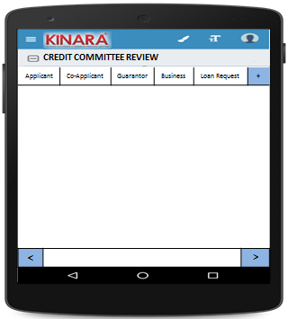

**4.2.1 Applicant**

Entity wise data display will start with Applicant

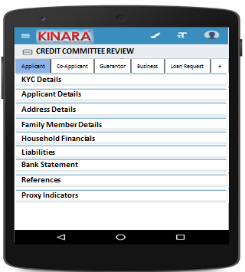

* + - 1. KYC Details:

All details will be auto-populated from Central Risk review stage

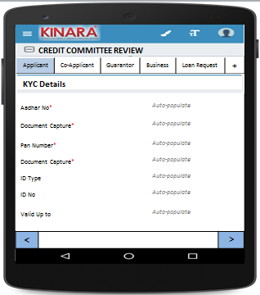

* + - 1. Applicant Details

All details will be auto-populated from Central Risk review stage

|  |  |  |
| --- | --- | --- |
| Page 1 | Page 2 | Page 3 |

* + - 1. Address Details

All details will be auto-populated from Central Risk review stage

|  |  |
| --- | --- |
| Page 1 | Page 2 |
| Page 3 | Page 4 |

* + - 1. Family Member Details

All details will be auto-populated from Central Risk review stage

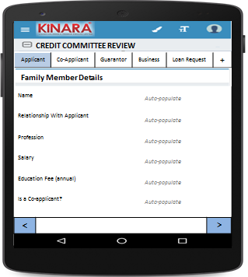

* + - 1. Household Financials

All details will be auto-populated from Central Risk review stage

|  |  |
| --- | --- |
| Page 1 | Page 2 |

* + - 1. Liabilities

All details will be auto-populated from Central Risk review stage

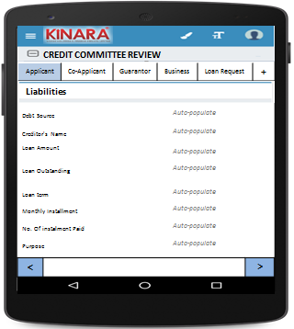

* + - 1. Bank Statement Details

All details will be auto-populated from Central Risk review stage

|  |  |
| --- | --- |
| Page 1 | Page 2 |

* + - 1. References

All details will be auto-populated from Central Risk review stage

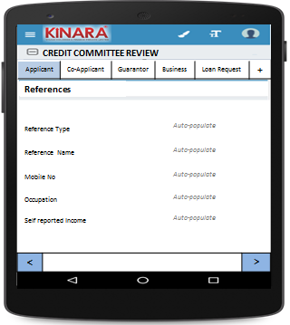

* + - 1. Proxy Indicators

|  |  |
| --- | --- |
| Page 1 | Page 2 |
| Page 3 | Page 4 |

* + 1. **Co-applicant**

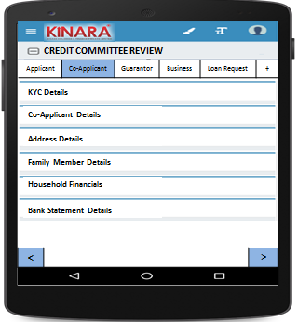

* + - 1. KYC Details

All details will be auto-populated from Central Risk review stage

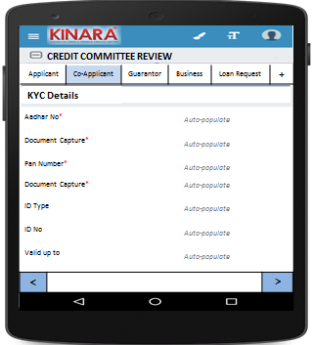

* + - 1. Co-applicant Details

All details will be auto-populated from Central Risk review stage

|  |  |  |
| --- | --- | --- |
| Page 1 | Page 2 | Page 3 |

* + - 1. Address Details

All details will be auto-populated from Central Risk review stage

|  |  |
| --- | --- |
| Page 1 | Page 2 |
| Page 3 | Page 4 |

* + - 1. Family Member Details

All details will be auto-populated from Central Risk review stage

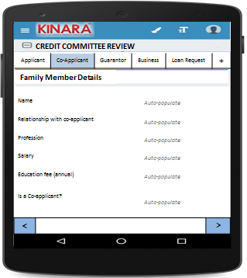

* + - 1. Household Financials  
         All details will be auto-populated from Central Risk review stage

|  |  |
| --- | --- |
| Page 1 | Page 2 |

* + - 1. Bank Statement Details

All details will be auto-populated from Central Risk review stage

|  |  |
| --- | --- |
| Page 1 | Page 2 |

* + 1. **Guarantor**

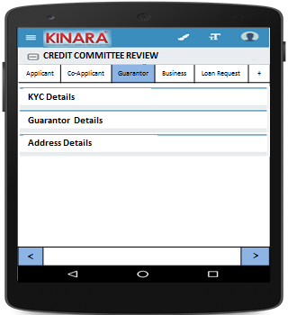

* + - 1. KYC Details

All details will be auto-populated from Central Risk review stage

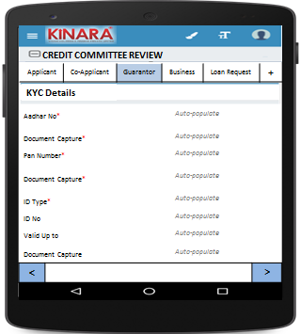

* + - 1. Guarantor Details

All details will be auto-populated from Central Risk review stage

|  |  |  |
| --- | --- | --- |
| Page 1 | Page 2 | Page 3 |

* + - 1. Address Details

All details will be auto-populated from Central Risk review stage

|  |  |
| --- | --- |
| Page 1 | Page 2 |
| Page 3 | Page 4 |

* + 1. **Business**

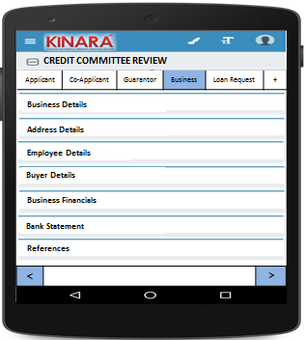

* + - 1. Business Details

All details will be auto-populated from field Central Risk review stage

|  |  |  |
| --- | --- | --- |
| Page 1 | Page 2 | Page 3 |

* + - 1. Address Details

All details will be auto-populated from Central Risk review stage

|  |  |
| --- | --- |
| Page 1 | Page 2 |

* + - 1. Employee Details

All details will be auto-populated from Central Risk review stage

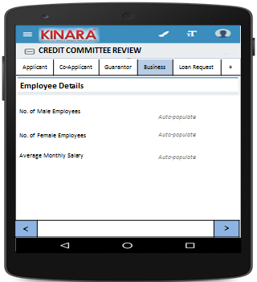

* + - 1. Buyer Details

All details will be auto-populated from Central Risk review stage

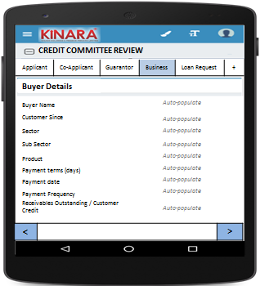

* + - 1. Business Financials

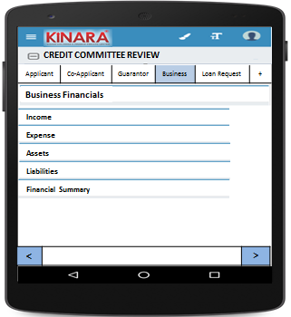

* + - * 1. Income

All details will be auto-populated from Central Risk review stage

|  |  |
| --- | --- |
| Page 1 – Through Sales | Page 2 – Other Business Income |

* + - * 1. Expense

All details will be auto-populated from Central Risk review stage

|  |  |
| --- | --- |
| Page 1- Raw material expense | Page 2 – Salary and wages |
| Page 3 – Fixed Obligations | Page 4 – Other Expenses |

* + - * 1. Assets

All details will be auto-populated from Central Risk review stage

|  |  |
| --- | --- |
| Page 1 – Current Assets | Page 2 – Inventory |
| Page 3 – Machinery (1) | Page 4 – Machinery(2) |
| Page 5 – Other Assets | |

* + - * 1. Liabilities

All details will be auto-populated from Central Risk review stage

|  |  |
| --- | --- |
| Page 1 – Fixed | Page 2 – Current |

* + - * 1. Financial Summary

All details will be auto-populated from Central Risk review stage

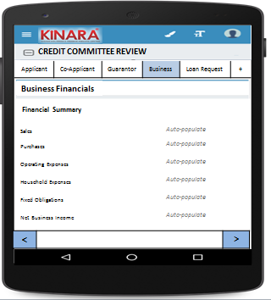

* + - 1. Bank Statement

All details will be auto-populated from Central Risk review stage

|  |  |
| --- | --- |
| Page 1 | Page 2 |

* + - 1. References

All details will be auto-populated from Central Risk review stage

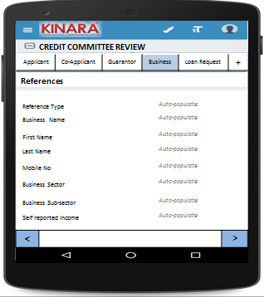

* + 1. **Loan Request**

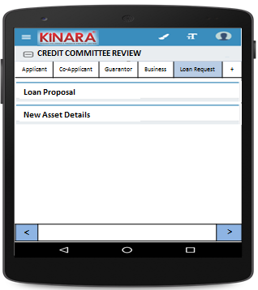

* + - 1. Loan Proposal

All details will be auto-populated from Central Risk review stage

|  |  |
| --- | --- |
| Page 1 | Page 2 |

* + - 1. New Asset Details

All details will be auto-populated from Central Risk review stage

|  |  |
| --- | --- |
| Page 1 | Page 2 |

* + 1. View Reference Check  
       All details will be auto-populated from Central Risk review stage

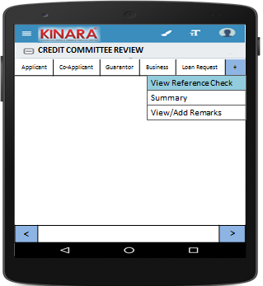

* + - 1. Reference Details

|  |  |
| --- | --- |
| Page 1 | Page 2 |
| Page 3 | Page 4 |

* + 1. Summary

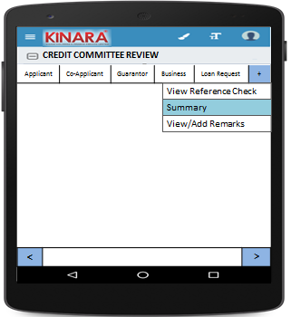

* + - 1. Ratios

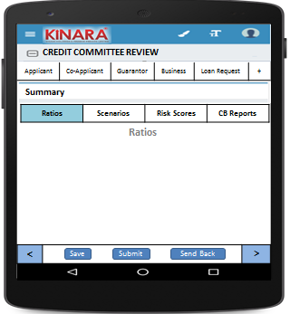

* + - 1. Scenarios

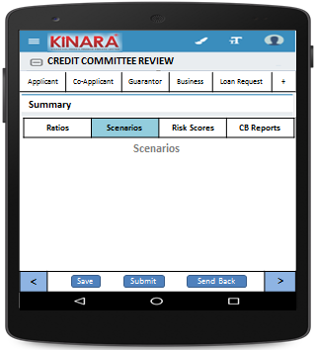

* + - 1. Risk Scores

|  |  |
| --- | --- |
| Page 1 | Page 2 |
| Page 3 | Page 4 |
| Page 5 | Page 6 |
| Page 7 | Page 8 |

* + - 1. CB Reports

|  |  |
| --- | --- |
| Page 1 | Page 2 |
| Page 3 | Page 4 |
| Page 5 | Page 6 |

* + 1. View/Add Remarks

|  |  |
| --- | --- |
| Page 1 | |
| Page 2 | Page 3 |

## Functional requirements

* 1. Once the profile is selected from the Credit Committee Review Queue, the member can view all the data captured and scores tabulated up to the field appraisal stage.
  2. CC Member will view all data and give remarks
  3. In case of any deviations, the CC member can send the loan back to any previous stage, or submit.
  4. On clicking ‘send back’ there should be option to choose which stage to send back to
  5. When Hold is selected, the application will be put on hold, will stay in the Central risk review Queue with a tag ‘On Hold’
  6. When Accepted the loan will automatically move to Loan Sanction queue
  7. When Rejected the loan application will sit in Rejected Application bucket

## Uploads

-NA-

## Downloads

-NA-

## Reports

-NA-

# Risk Score 3

## UI specification

## Screenshot

## Functional requirements

## Upload

## Download

## Reports